**Q )Design a Program for creating machine that accepts three consecutive one.**

**CODE : -**

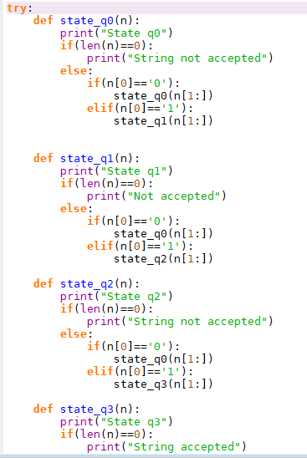

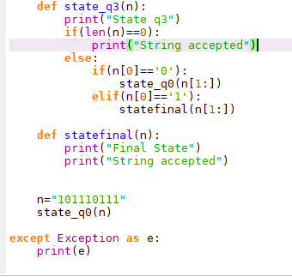

**OUTPUT : -**

